1. 
2. 
3. Last of the Bullish Pattern we will talk in this course.
4. Till now, this one is the most powerful pattern. Even more powerful than Bullish Engulfing Pattern.
5. **From Youtube**:  
   A diagram of candlestick patterns

   Description automatically generated  
   A graph of different colored rectangles

   Description automatically generated  
     
   Let’s look at the criteria for identifying Morning Star Patterns.
6. A close-up of a paper

   Description automatically generated
7. **1st Candle**: Must be **Long Black Real Body**.
8. **2nd Candle**:
   1. Small Real Body. Spinning Top (Black or White).
   2. There must be gap b/w 1st and 2nd. Means if 2nd black, then opening should be below the closing of the 1st but if 2nd white, then closing of it must be below the closing of the 1st candle.  
      A graph of different colored rectangles

      Description automatically generated  
      If their Shadows are overlapping, it is not a problem.  
      **NOTE**: We are not covering start in this course Level 1. There is an entire course on Star.
9. Why this pattern is the most powerful?
   1. Because 1st candle represents **that the bears are in complete control** in the market.
   2. 2nd Candle represents the **indecision**. So, the market is taking a breath here.
   3. 3rd Candle: Suddenly, the battle is won by the bulls because they pushed the price above the midpoint of the 1st Black Real Body.
10. This must come after downtrend which is also applicable for other 3 bullish patterns (Hammer, Bullish Engulfing Pattern, Piercing Pattern).
11. Let us take a quick look at charts.  
    The following chart is of **Grasim**.  
    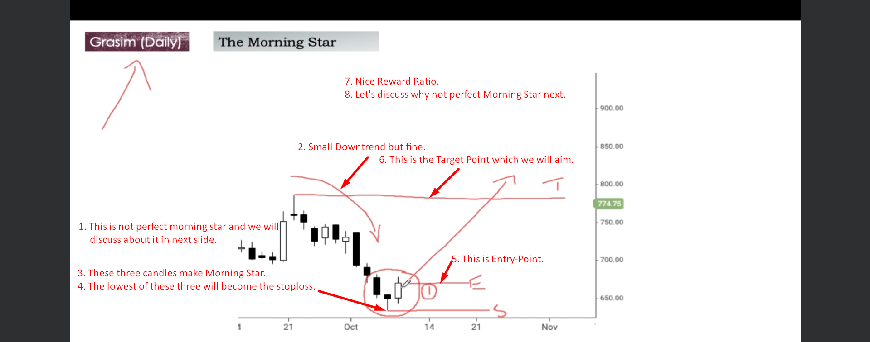
12. Reason why above slide is not Perfect Morning Start.  
    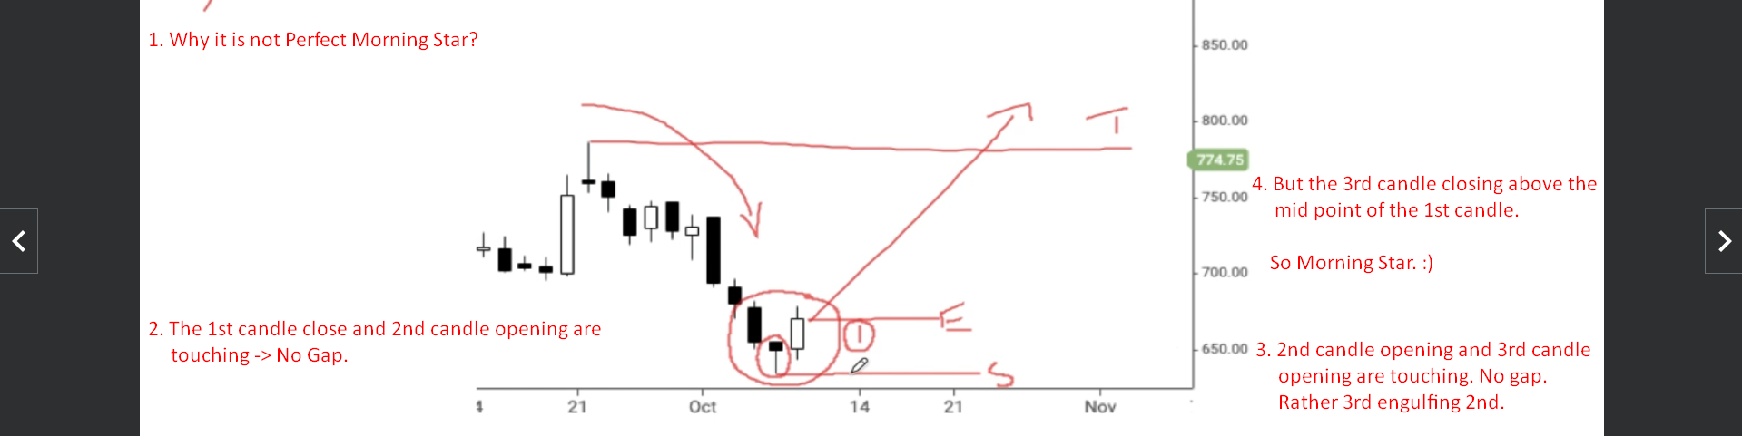
13. What positive signals we get from the above chart to take the trade?  
    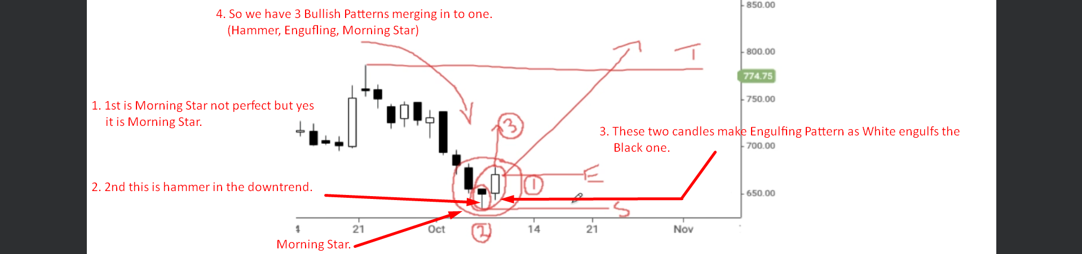
14. So, we have three bullish signals but note we don’t have prior support.  
    